**PROBLEM REPORT**

**TABLEAU HR SCORECARD:**

**MEASURING SUCCESS IN TALENT MANAGEMENT**

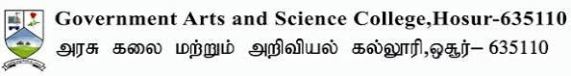

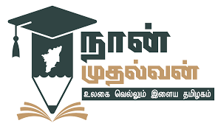

Submitted By:

T.Kaviarasan ,

E.Arunkumar,

K.Jeevashakthiraj,

P.Chandu.

**Under The guidance of** :

Prof : A.Ganesh,

Department of Mathematics.

**CONTENTS**

|  |  |
| --- | --- |
| **No.** | **Topics** |
| **1** | **Introduction** |
| **2** | **Talent management model** |
| **3** | **Project Plan** |
| **4** | **Design Strategy** |
| **5** | **Advantages and Disadvantages** |
| **7** | **Steps of great talent management** |
| **8** | **Conclusion** |

**INTRODUCTION**

In today’s free trade, every organization for viability needs high potentials workforce. Organizations

require the best talent to thrive in the growingly intricate world economy (Wellins et al., 2008). New

environment characteristics breed emerging problems in retention of the biggie. Every Human

Resource (HR) manager faces big stumbling to motivate and retain the best employees in organization.

HR experts admit matching the right talent with the right job profile effectuates superb performance.

Attracting and retaining talented crews are pressing dilemma in workplace and talent management

grips key priority for many organizations. However, inadequacy of talented workforce is perceptibly

still critical as competent personnel is key to higher performance and competition. To overcome

inadequacy, organizations must be perceptive to optimize the talents and safeguard their retention for

In today’s free trade, every organization for viability needs high potentials workforce. Organizations

require the best talent to thrive in the growingly intricate world economy (Wellins et al., 2008). New

environment characteristics breed emerging problems in retention of the biggie. Every Human

Resource (HR) manager faces big stumbling to motivate and retain the best employees in organization.

HR experts admit matching the right talent with the right job profile effectuates superb performance.

Attracting and retaining talented crews are pressing dilemma in workplace and talent management

grips key priority for many organizations. However, inadequacy of talented workforce is perceptibly

still critical as competent personnel is key to higher performance and competition. To overcome

inadequacy, organizations must be perceptive to optimize the talents and safeguard their retention for

In today’s free trade, every organization for viability needs high potentials workforce. Organizations

require the best talent to thrive in the growingly intricate world economy (Wellins et al., 2008). New

environment characteristics breed emerging problems in retention of the biggie. Every Human

Resource (HR) manager faces big stumbling to motivate and retain the best employees in organization.

HR experts admit matching the right talent with the right job profile effectuates superb performance.

Attracting and retaining talented crews are pressing dilemma in workplace and talent management

grips key priority for many organizations. However, inadequacy of talented workforce is perceptibly

still critical as competent personnel is key to higher performance and competition. To overcome

inadequacy, organizations must be perceptive to optimize the talents and safeguard their retention for

***Talent management*** is a constant process that involves attracting and retaining high-quality employees, developing their skills, and continuously motivating them to improve their performance.

The primary purpose of talent management is to create a motivated workforce who will stay with your company in the long run. The exact way to achieve this will differ from company to company.

Talent management naturally encompasses many of the responsibilities of HR.

All the same, it is not enough to expect that just because you have an HR department, you are managing talent.

You need to have a talent management strategy in place designed just for your company to gain optimal results.

Talent management includes all the ways that organizations bring employees on board, keep them happy and productive, and help them continue to develop their skills over time.

Companies preparing for [the future of work](https://www.mckinsey.com/featured-insights/mckinsey-explainers/what-is-the-future-of-work) can take a variety of steps to [help employees build skills](https://www.mckinsey.com/capabilities/people-and-organizational-performance/our-insights/three-keys-to-building-a-more-skilled-postpandemic-workforce) and continue learning and growing—this is vital, especially considering that hiring new workers can be twice as expensive as upskilling or reskilling existing employees.

[Building workforce skills](https://www.mckinsey.com/capabilities/people-and-organizational-performance/our-insights/building-workforce-skills-at-scale-to-thrive-during-and-after-the-covid-19-crisis), via training and reskilling or upskilling, will be essential to support new ways of working and new business priorities. And focusing on skills—particularly social and emotional skills (sometimes called soft skills), including empathy, [leadership](https://www.mckinsey.com/featured-insights/mckinsey-explainers/what-is-leadership), and [adaptability](https://www.mckinsey.com/capabilities/people-and-organizational-performance/our-insights/future-proof-solving-the-adaptability-paradox-for-the-long-term)—can help close existing skill gaps.

**Talent Management Model**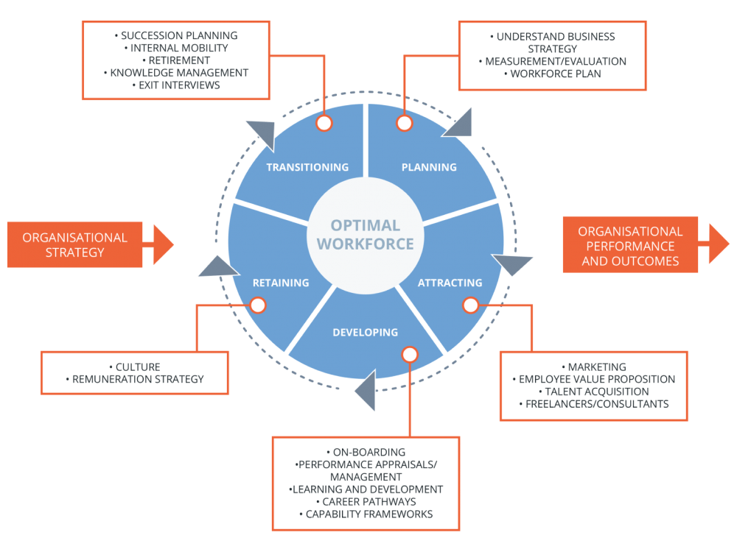

**Project Plan**

Planning aligns your talent management model in line with the overall goals of your organization.

Only with the correct planning can you ensure that you seek talent with the right skills and experience. In addition, it assesses current employees to see what is working well for the company.

For instance, if employees with certain characteristics tend to stay at the organization for longer, you should plan to hire more workers like them.

Design Strategy

A talent management strategy is based on the talent management model. It should match your organization’s goals and clearly define what type of talent you need.

You organize the talent management process based on the talent management strategy.

The development part of the model involves taking steps to help talent grow within the company.

It should be aligned with the [employee development plan](https://www.valamis.com/hub/employee-development-plan) and includes identifying roles where particular employees could move to in the future as well as considering how to expand workers’ skills and knowledge to fulfill new challenges facing your organization.

Talent management also looks at what will keep employees at your company enthusiastic and willing to go the extra mile. It is necessary to provide employees with value.

Motivation also requires the correct onboarding — to give new hires a great impression of your company from the very beginning. This will increase the chance that they stay with the company and work hard.

**AVANTAGES AND DISADVANTAGES**

There are few different types strategies you can choose from.

Strategy #1: Hire Only Top Employees

**The advantages of this strategy are obvious:**

* You immediately receive top talent.
* The employees will perform well and probably reach high performance faster.
* You are able to grow your company faster.
* You are more prepared for challenges and risks.

**However, there are some disadvantages:**

* It’s expensive, and will cost you even more if you end up needing to hire someone else.
* It could be more difficult to retain top talent.
* The hiring process may take longer, as you’ll probably want to select from a wider pool of candidates.
* It can be challenging to manage team of top talent.
* Having too many top performers on a team can lead to competition and result in underperformance.

Strategy #2: Hire Promising Specialists and Develop Them

**This second option has a couple advantages:**

* You can find talent faster. This may be necessary if you are in urgent need for talent and have insufficient time to search for top employees.
* You will likely save money on salaries.
* The employee has the potential to become a skilled and loyal professional.
* You can hire two, or even three, promising specialists for the same amount as for one top performer.

**The main disadvantages are:**

* Your company may grow slower.
* Compared to top talent, these hires lack of knowledge. This can lead to lower performance.
* You may need to hire another specialist if the employee cannot handle the role.
* It requires a larger investment in development.
* The strategy may fail entirely and you’ll need to revert to option 1.

Strategy #3: Combine Strategies 1 and 2

This quote describes the strategy best:

*“Your team’s strength is not a function of the talent of individual members. It’s a function of their collaboration, tenacity, and mutual respect.”*

**Finally, the pros of combining the two above are:**

* It gives you the best of both worlds.
* It also allows you to take advantage of a combination of new hires and existing talent.
* Having top talent and potentially good specialists (e.g. young employees) will help the specialists grow faster and motivate them.
* It leads to knowledge transfer — top talent can teach other employees.

**All the same, there is one con:**

* If you have specific requirements (such as you are in urgent need of growth or if you are on a tight budget), sticking to a single strategy may be more appropriate

### The 7 Steps of a Great Talent Management Process

The following steps cover what you need to do to develop a continuous talent management process for your organization.

It covers how to find the most talented people available and then help them stay in your company.

#### Step 1: Specify What Skills You Need

What is the first step in the talent management process?

Before you can go any further, you must determine what kinds of hires you need and what requirements they should fill.

Consider if it would be possible to teach existing employees to avoid the need to hire anyone new.

#### Step 2: Attract the Right People

There are several stages to attracting talent:

1. Create targeted advertisements and post them on top job sites — HR branding is helpful here.
2. Plan interviews and other means to identify the best person for the job. In addition to regular questions, consider using personality assessments, references, and tests that require candidates to perform in real-life situations.
3. Hire your top choices.

#### Step 3: Onboard and Organize Work

Help new employees feel orientated by being ready for them as soon as they enter the company.

Know what tasks you will set them, have training sessions scheduled, and assign current employees to support new workers settle in.

#### Step 4: Organize Learning and Development

Remember, it is often easier to develop the skills of your current employees than to hire new talent.

Plus, even if you do hire top talent, they will likely want to learn something in their new role.

Plan ways for your workers to learn and grow, such as through conferences, courses, and a learning management system to create a learning environment.

#### Step 5: Hold Performance Appraisals

Checking employee performance regularly allows you to see if workers could manage additional responsibilities.

This could save you hiring new talent and it may help an employee prepare for a promotion.

#### Step 6: Strategize to Retain Your Best Talent

Keep employees satisfied at work through promotions, benefits, motivating tactics, ensuring job satisfaction, and improving company culture.

#### Step 7: Plan for Successions

Nurture employees for successions, such as for when a senior member of staff retires.

Enable employees to perform to their best through continuous learning opportunities, including knowledge management.

If an employee decides to leave the company, conduct an [exit interview](https://www.valamis.com/hub/exit-interview) to find out what went wrong — this will help you prevent the same issue occurring again in the future.

**Conclusion**

You need to stop assuming that you already have talent management covered just because you have HR at your company. Talent management rarely happens naturally.

You need a strategy that is tailored to your business alone. Only like this will you obtain and retain top talent and gain a competitive advantage over other businesses in your industry.